|  |  |
| --- | --- |
| **Course Code: CSL601** | **Course Name: SE-LAB** |
| **Class : TE-CO** | **Batch : 3** |
| **Roll no : 18CO63** | **Name : SHAIKH TAUSEEF MUSHTAQUE ALI** |

**Experiment : 07**

**Aim : Develop Activity Diagram / State Diagram for the project.**

**Output :**

**ACTIVITY DIAGRAM:**

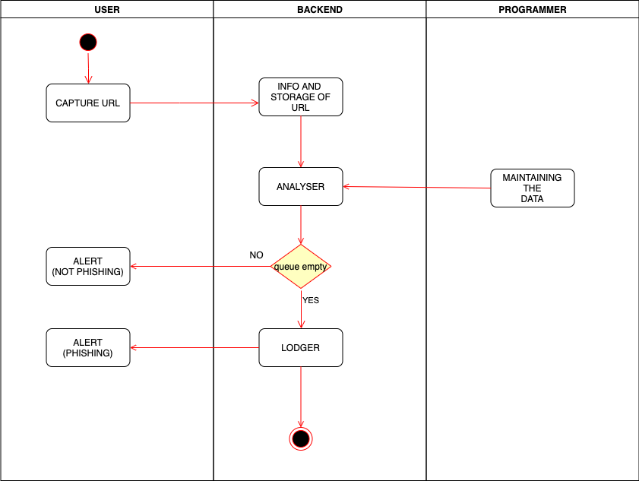

**STATE DIAGRAM:**

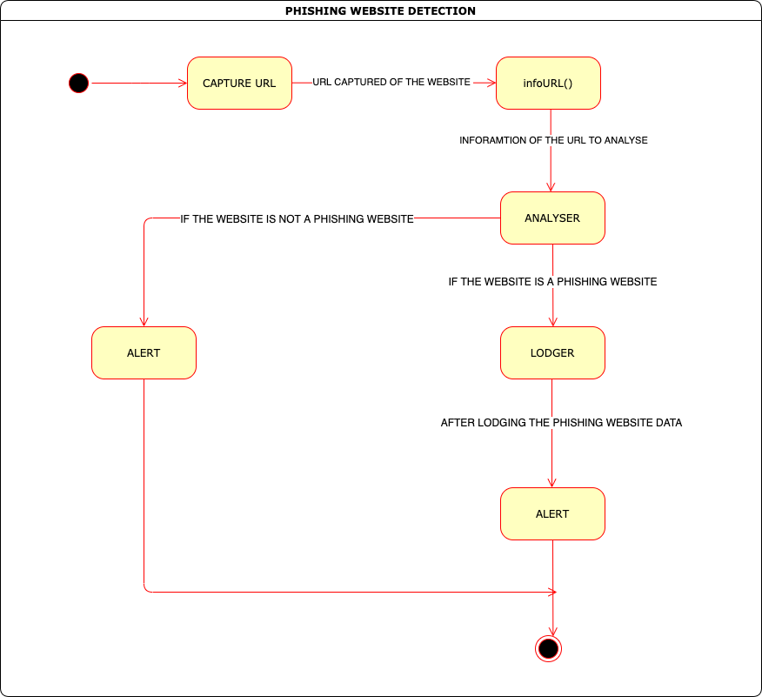

**Reference:**

[**https://www.visual-paradigm.com/guide/uml-unified-modeling-language/what-is-activity-diagram/**](https://www.visual-paradigm.com/guide/uml-unified-modeling-language/what-is-activity-diagram/)

[**https://www.lucidchart.com/pages/uml-activity-diagram**](https://www.lucidchart.com/pages/uml-activity-diagram)

[**https://www.visual-paradigm.com/guide/uml-unified-modeling-language/what-is-state-machine-diagram/**](https://www.visual-paradigm.com/guide/uml-unified-modeling-language/what-is-state-machine-diagram/)

[**https://www.lucidchart.com/pages/uml-state-machine-diagram**](https://www.lucidchart.com/pages/uml-state-machine-diagram)

[**https://www.draw.io/**](https://www.draw.io/)

[**https://creately.com/**](https://creately.com/)

**Conclusion:**

|  |
| --- |
| WITH THE HELP OF THIS EXPERIMENT WE ARE ABLE TO CREATE ACTIVITY AND STATE DIAGRAM FOR OUR |
| PROJECT TOPIC. |